TILE OF THE PAPER (MAXIMUM 2 ROWS, TIMES NEW ROMAN, 14 PT., BOLD, CENTERED)
AUTHOR 1 (FIRST AND LAST NAME), AUTHOR 1 ()…… maximum 3 authors
Affiliation 1, email 1
Affiliation 1, email 1
Abstract: The guideline explains how to prepare your paper in printer-ready format for the International Scientific Conference of the Romanian German-University of Sibiu, so that its appearance is clear and consistent with the other papers in the proceedings. It includes guidance on layout, illustrations, text style and references, presented exactly as your paper should appear. It is highly advised to use URGS Conference 2012 Template and strictly follow the instructions to prepare your paper in Microsoft Word 2003 or later versions. The abstract portion is a narrative presentation without references. The abstract should give a concise and informative description of the paper, in 200 - 300 words, written to interest the reader as well as for information retrieval.
Keywords: no, more, than, 5, keywords
JEL (Journal of Economic Literature) Classification:
http://www.aeaweb.org/journal/jel_class_system.html

1. INTRODUCTION
The guideline is designed to achieve uniformity in the papers appearing in the International Scientific Conference of the Romanian-German University of Sibiu 2012 proceedings. It explains how to prepare an electronic printer-ready version. Your paper will be printed “AS IS”. Please use the specific styles defined in the 2012 URGS Conference Paper Template and this document to format your paper. The official language of the conference is English. If English is not your mother tongue, make sure that the English is checked by a competent editor.
The Authors guideline is available in Microsoft Word 2003 on the 2012 Conference Web Site in the Paper Format section: http://www.roger-univ.ro/ConferintaURGS/index.html. The paper manuscript must provide the details of the presented work to readers. It should be divided into clear sections, each with a heading, so that a reader can follow the logical development of the work.

2. REDY FOR PRINT MANUSCRIPT
The paper must not exceed 10 pages (the final paper must have even pages). Prepare your printer-ready paper in A4-size (21 cm × 29.7 cm). Please do not change the paper size and the styles. The easiest way to format your paper is to use the template file “2012 URGS Conference Paper Template.doc” downloadable from the conference web site. If you do not want to use this template, please strictly follow the instructions provided in this document to format your paper.

2.1. Format
Your manuscript must fit within the required margins. In formatting your page A4 (21 cm × 29.7 cm), set your margins at 3,0 cm for top and 2,5 cm for bottom, left, and 2,0 cm for right for the entire document. Do not worry about page headlines and page numbers. Both will be inserted and modified later.
2.2. Numbering and Attributing
Use Arabic numbers and Capital Letters section headings and small caps for subsection headings. Subsections should be numbered as shown. Use bold face for the paper title and the headings of sections and subsections.

3. FIGURES AND TABLES
Figure captions should be below the figures as shown in Figure 1, and table captions above the tables.
Table 1: The analysis of the ..........
Indicator | 2001 | 2002 | 2003 | 2004 | 2005
Average | 17.50 | 10.94 | 5.97 | 4.61 | 8.23
Dispersion | 258.67 | 127.35 | 246.36 | 274.99 | 153.49
Standard deviation | 16.08 | 11.28 | 15.70 | 16.58 | 12.39
Source: Statistical journal of...............
It would be preferable to digitize your figures and pixel graphics with a resolution of 300 dpi, which still allows printing without quality degradation. Higher resolutions enlarge the data without significant improvement printing quality.

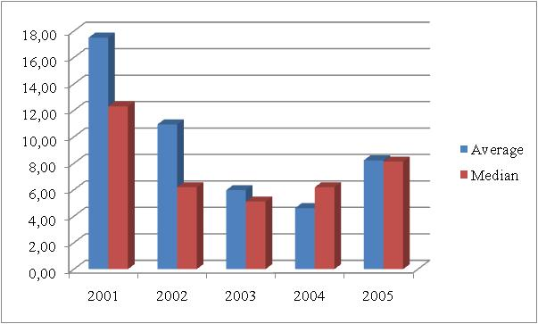
Figure 1: The dynamic of the average and the median in 2001 – 2005
Source: Statistical journal of...............
Please note that the conference proceedings printout will be realized with grayscale pictures and in color for the CD format. Check the readability of your colored figures after they have been printed in grayscales. Do not use such explanations in your text like “the red line in figure x in comparison to the green line.

4. EQUATIONS AND REFERENCES

Number equations consecutively with equation numbers in parentheses flush with the right margin. Italicize symbols for quantities and variables but not function names (cos, exp, etc.), and units. Be sure that the symbols in your equation have been defined before the equation appears, or their definitions follow the equation immediately.
(1)

where, = variable one and = variable two.
4.1. References
References to the literature in the main text should use the form: Porter (1998); Stiglitz (1997a); (Stiglitz, 1992; Stiglitz, 1996); (Stiglitz, 1997, p. 190); (IMF, 2009). Footnotes should be avoided. References should be set out in alphabetical order of the author's name in a list at the end of the paper.
4.2. Full paper submission
Please send us your paper in .doc format only by sending it at the email address: conference@roger-univ.ro, together with the paper registration form that you will find on the Conference website: http://www.roger-univ.ro/ConferintaURGS/index.html.
All submissions are subject to a double blind review process. Papers will be evaluated for originality, significance, clarity, and contribution. After the official acceptance of your full paper is issued, please complete your registration

5. CONCLUSIONS
By submitting your paper, you agree and accept the commitment that at least one of the co-authors will present the paper in person at the 2012 International Scientific Conference of the Romanian-German University of Sibiu conference.
Accepted and presented papers will be published in the CD Conference Proceedings with ISBN, as well as in written format edited in partnership with Lambert Academic Publishing from Germany.

6. REFERENCES
- Boyd, D.M., Ellison, N., B., (2007), Social network sites: a definition, history and scolarship, Journal of Computer Mediated Communication, vol.13, (1), available at http://jcmc.indiana.edu/vol13/issue1/boyd.ellison.html, on the 01.01.2012;
- Kotler, P., Kartajaya, H., Setiawan, I., Marketing 3.0 – de la produs la consumator şi spiritul uman, Publica Publishing House, Bucharest, 2010, p. 20;
- Veghes, C., Pantea, C., (2009), Social networking: reasons to join and things done by the romanian consumer, Journal of the Unversity of Oradea - economics, vol. 4 (1), pp. 869-873;
- *** Legea nr. 1 / 2011 – Legea Educatiei Nationale, available at http://www.edu.ro/index.php/base/frontpage, on the 01.05.2012.
- ***Eurostat 2011, Information society statistics, available at http://epp.eurostat.ec. europa.eu /portal/page/portal /information_society/data/main_tables on the 15.07.2012

