TILE OF THE PAPER (MAXIMUM 2 ROWS, TIMES NEW ROMAN, 14 PT., BOLD, CENTERED)
AUTHOR 1 (FIRST AND LAST NAME), AUTHOR 1 ()…… maximum 3 authors
Affiliation 1, email 1
Affiliation 1, email 1
Abstract: The guideline explains how to prepare your paper in printer-ready format for the Annals of the Romanian-German University of Sibiu - Economics, so that its appearance is clear and consistent with the other papers in the proceedings. It includes guidance on layout, illustrations, text style and references, presented exactly as your paper should appear. It is highly advised to use Template provided by URGS and strictly follow the instructions to prepare your paper in Microsoft Word 2003 or later versions. The abstract portion is a narrative presentation without references. The abstract should give a concise and informative description of the paper, in 200 - 300 words, written to interest the reader as well as for information retrieval.
Keywords: no, more, than, 5, keywords

1. INTRODUCTION
The guideline is designed to achieve uniformity in the papers appearing in the Annals of the Romanian-German University of Sibiu - Law. It explains how to prepare an electronic printer-ready version. Your paper will be printed “AS IS”. Please use the specific styles defined in the present Paper Template and this document to format your paper. The official language of the journal is English. If English is not your mother tongue, make sure that the English is checked by a competent editor.
The Authors guideline is available in Microsoft Word 2003 on URGS Annals Web Site in the Paper Format section. The paper manuscript must provide the details of the presented work to readers. It should be divided into clear sections, each with a heading, so that a reader can follow the logical development of the work.
2. READY FOR PRINT MANUSCRIPT
The paper must be between 4 and 16 pages long (the final paper must have even pages). Prepare your printer-ready paper in A4-size (21 cm × 29.7 cm). Please do not change the paper size and the styles. The easiest way to format your paper is to use the template file “Paper Templete.doc” downloadable from the Journal web page. If you do not want to use this template, please strictly follow the instructions provided in this document to format your paper.
2.1. Format
Your manuscript must fit within the required margins. In formatting your page A4 (21 cm × 29.7 cm), set your margins at 3,0 cm for top and 2,5 cm for bottom, left, and 2,0 cm for right for the entire document. Do not worry about page headlines and page numbers. Both will be inserted and modified later.

2.2. Numbering and Attributing
Use Arabic numbers and Capital Letters section headings and small caps for subsection headings. Subsections should be numbered as shown. Use bold face for the paper title and the headings of sections and subsections.
3. FIGURES AND TABLES
Figure captions should be below the figures as shown in Figure 1, and table captions above the tables.
Table 1: The analysis of the ..........
Indicator | 2001 | 2002 | 2003 | 2004 | 2005
Average | 17.50 | 10.94 | 5.97 | 4.61 | 8.23
Dispersion | 258.67 | 127.35 | 246.36 | 274.99 | 153.49
Standard deviation | 16.08 | 11.28 | 15.70 | 16.58 | 12.39
Source: Statistical journal of...............
It would be preferable to digitize your figures and pixel graphics with a resolution of 300 dpi, which still allows printing without quality degradation. Higher resolutions enlarge the data without significant improvement printing quality.

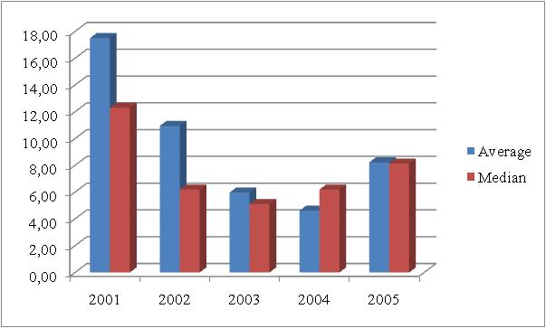
Figure 1: The dynamic of the average and the median in 2001 – 2005
Source: Statistical journal of...............
Please note that the conference proceedings printout will be realized with grayscale pictures and in color for the online version. Check the readability of your colored figures after they have been printed in grayscales. Do not use such explanations in your text like “the red line in figure x in comparison to the green line.
4. EQUATIONS AND CITATION
Number equations consecutively with equation numbers in parentheses flush with the right margin. Italicize symbols for quantities and variables but not function names (cos, exp, etc.), and units. Be sure that the symbols in your equation have been defined before the equation appears, or their definitions follow the equation immediately.
$a=\frac{1}{2}∗b$ (1)
where, $a$ = variable one and $b$ = variable two.
4.1. Citation
Citations to the literature in the main text should use the form: (Nicolescu, 1998); (Nicolescu and Verboncu, 2000) (Stiglitz, 1992; Stiglitz, 1996); (Balaure, 2003, p. 29); (IMF, 2009). (Kotler et.al, 1998, – for more than 2 authors). Footnotes are not allowed.
4.2. Full paper submission
Please send us your paper in .doc or .docx format only at the email address: anale.drept@roger-univ.ro, within the deadlines presented on the web site and bellow.
All submissions are subject to a double blind review process. Papers will be evaluated for originality, significance, clarity, and contribution. After the official acceptance of your full paper is issued, please check the Journal web page after the publication date for your paper.
5. DEADLINES
- July 1st, 2015 – Full paper submission;
- October 15th, 2015 – Notification of paper acceptance or rejection;
- December 15th, 2015 – Publication of the Annals of U.R.G.S. – Law.
6. REFERENCES
References must be set out in alphabetical order of the author's name in a list at the end of the paper.
- Slavoiu, R., Lancrajan, A., Acordul de recunoastere a vinovatiei, available at http://juridice.ro , on the 01.01.2012;
- Neagu, I., Criminal Procedure. Treaty, Global Lex Publishing House, Bucharest, 2002, p. 676;
- Sima, C., (2011) Hierarchical control in the Public Ministry, in Penal Law Review, no. 1/2011, p. 58-60;
- ***Legea nr.17/2000 privind asistenta sociala a persoanelor varstnice, available at http://www.edu.ro/index.php/base/frontpage, on the 01.05.2012.
- ***Eurostat 2011, Information society statistics, available at http://epp.eurostat.ec. europa.eu /portal/page/portal /information_society/data/main_tables on the 15.07.2012

